**j. Groom Wedding collection**

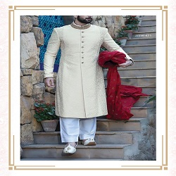

**CREAM COLOR SHIRWANI WITH RED TURBAN**

PKR48.000.00

* Shirwani size: Medium
* Pajama: 2.5 Meters

**MORE INFORMATION:**

* color: Cream and white
* Wear Type: Wedding
* Product Category: Groom shirwani
* Volume : Volume 4 2022
* Collection: Festive Affair '22
* Sizes: Smal, Medium , large
* Fabric: katee
* Disclaimer: Due to the photographic lighting & different screen calibrations, the colors of the original product may slightly vary from the picture